Making an Existing PDF Accessible
(ADA Compliant)

Contents
Introduction 3
Accessibility Checker Report 3
A. Checking an Existing PDF for Accessibility Issues 3
Tags 5
B. About Tagging 5
C. Adding Tags to a PDF 5
D. Adding Tags to Annotations 6
E. Adding Tags to Decorative Images 8
Titles 10
C. Adding a Title to a PDF 10
Images 12
D. Adding Alternative Text to Images, Shapes or Other Graphics. 12
Tables 12
E. Adding Headings and Alt Text to Tables 12
F. Define the PDF Language 13

Introduction
  - Before any document is placed on the Broward College Public site, it needs to be ADA complaint. Use the instructions below to ensure that your PDF document will be accessible to all website users. It also ensures that all content is readable when using devices such screen devices.

Accessibility Checker Report

A. Checking an Existing PDF for Accessibility Issues
- Open the Accessibility panel by clicking on the Tools options on the right.

- Under Accessibility, click on Full Check.

- An Accessibility Checker Options dialog window will display and then click the Start Checking button.

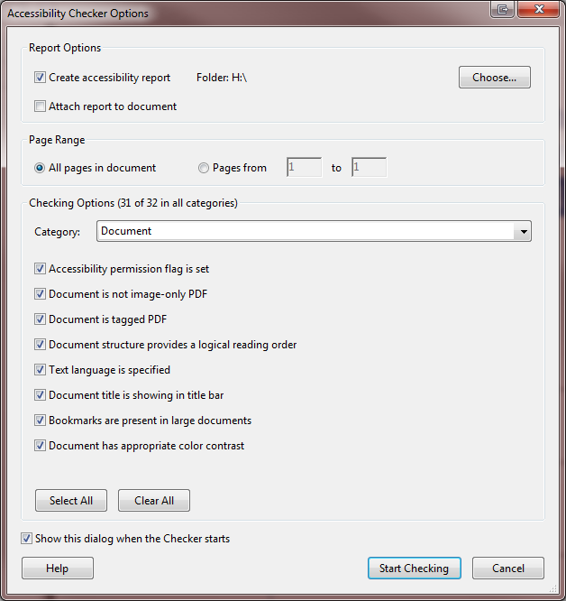
- The Accessibility Checker panel will display on the left side indicating the document issues broken down by elements (document, page content, forms, alternate text, tables, lists and headings).
- Click on the (+) to dig down to the specific issue.
- Right-click on the item with a red (X) to use the feature Fix or Explain. This will help you resolve the issue.

Tags

B. About Tagging
Tagging the elements in a PDF allows users to read and render content using devices such as screen readers. When adding tags to images, you have two types of images: informative or decorative. Images that are intended to be known to the reader should be tagged as FIGURE. If the image is just for decoration purposes then it should be tagged BACKGROUND.

C. Adding Tags to a PDF
There are two ways to tag content - paragraphs, images, links, etc. You can use the Touch Up Reading Order or Add Tags to Document (Acrobat Pro DC has Autotag Document).

Touch Up Reading Order
- Open the Accessibility panel by clicking on the Tools options on the right.
- Click on Touch Up Reading Order.
- Select any item on the page such as an image. A Touch up Reading Order window will allow you to tag the content as text, figure, form, table, etc.
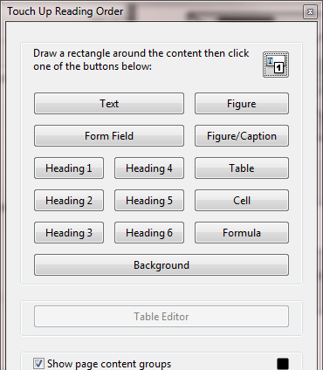
- Continue to move down the document until all the items have been tagged. There is also a right click menu for quicker tagging.

Using the Add Tags to Document Feature

- Open the Accessibility panel by clicking on the Tools options on the right.
- Click on the Add Tags to Document.
- Then a window will display “This document is already tagged. Would you like to retag the document?”
- Click Yes.
- Run a Full Check again to see if this solved some of the issues. Otherwise, continue tagging manually by using the Touch Up Reading Order steps.

D. Adding Tags to Annotations

- Go to the Accessibility Checker Panel. Right-click the next to the element, then select the Show in Content Panel option from the menu.

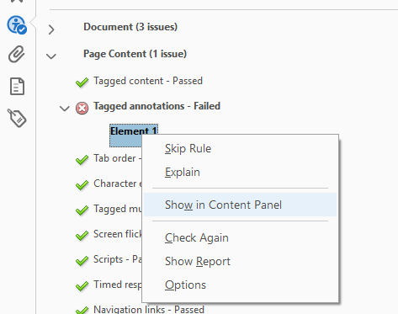

- Then the Content Panel will display. Note that there are two types of annotations: links and fillable form fields. The one below is a fillable form field. Click on the Find….option from the menu.

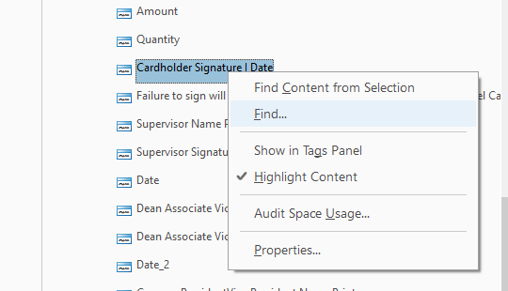

- Next, the Find Element will display. Select Unmarked Annotations from the Find menu.

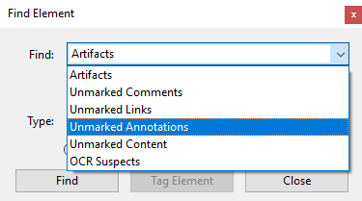

- Click on the Find button. Note that the Type section changes and displays the element name. Right now it states Cardholder Name_2.
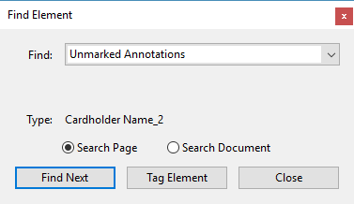

- Click on the Tag Element button and the New Tag dialog box will display. Select Form from the Type drop box.

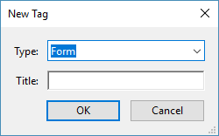
- Make sure to fill in the Title field too!
- Finally, click OK and continue this process for the rest of the annotations.
- If the Annotation is a blank space then tag it using the Article option.
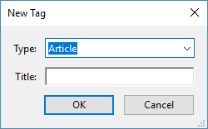

E. Adding Tags to Decorative Images
Graphics or images that are not important to the document’s content should be tagged as “artifacts” or “background”. This will help the assistive technologies distinguish between decorative images and images that make up the substance of the document. When decorative images are tagged as an artifact then this will cause assistive technologies to skip over it.
For images, charts and other non-text graphics, we assign a <Figure> tag. These require either alternative text or actual text in order to make it accessible.
- Under Page Content, expand the Tagged Content issue to display all the elements.
- Then right-click on Element 1. Choose Show in Content Panel.
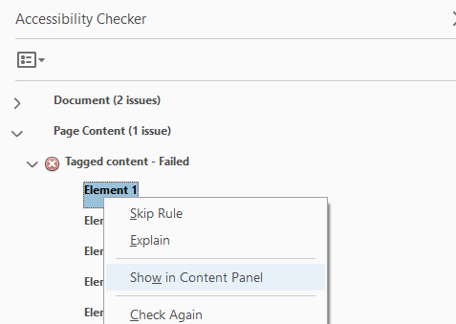
- The Content Panel will display highlighting element 1.
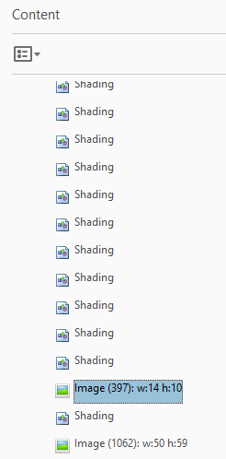
- Right-click on the image and select Create Artifact.
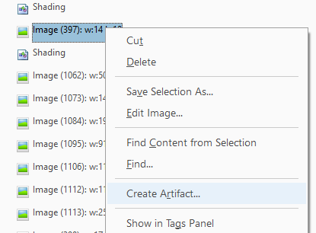
- The Create Artifact dialog box will display. Click on Ok.
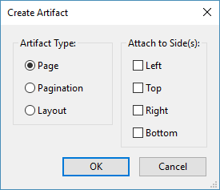
- Follow steps 1-5 for the rest of the elements.

Titles

C. Adding a Title to a PDF
The title states the topic of the document.

- Open the Accessibility Checker panel and click on the (+) next to Document.
- Go down to Title and right-click to select the Fix option from the menu.
- Enter the document title in the Description dialog box (deselect Leave As Is, if necessary).
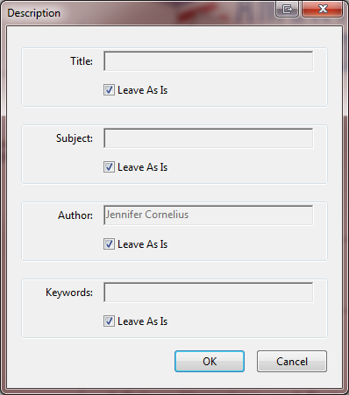

OR

- Choose File and then select Properties.
- Click on the Description tab.
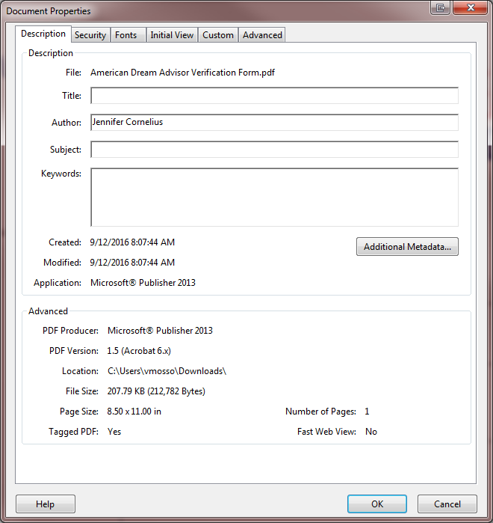

- Enter a title in the Title text box.
- Click Initial View, and then choose Document Title from the Show drop-down list.
- Click OK.

Images

D. Adding Alternative Text to Images, Shapes or Other Graphics.
If an image is used as a decoration, or background, or other purpose with no function, it should be defined as "artifact". If an image conveys information, then alt text and description should be used.

- Open the Accessibility panel by clicking on the Tools options on the right.
- Then click on Set Alternate Text.
- A window will display with the following message “Acrobat will detect all figures in this document and display associated alternate text. Click OK.
- The images on the document will be highlighted and a window will display to insert an alt text or to mark it as a decorative figure.

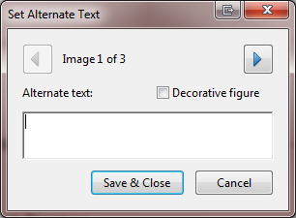
- Save & Close.

Tables

E. Adding Headings and Alt Text to Tables
If a table conveys information then alt text and a description should be used.

Table Heading
- Open the document, click under the Accessibility panel.
- Click on Add Tags to Document.

OR
- Open the Accessibility panel by clicking on the Tools options on the right.
- Click on Touch Up Reading Order.
- Select the table on the page.
- A dialog box with display, click on Table Editor.
- Right-click on the header cell and select Table Cell Properties. Change to Header Cell (radio button).
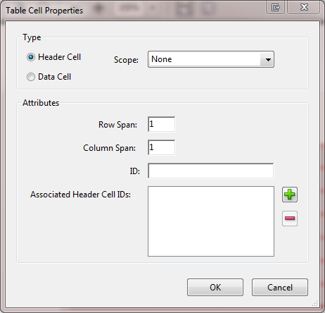

Alt Text
- Open the Accessibility panel by clicking on the Tools options on the right.
- Open the document and do a Full Check.
- The Accessibility Checker panel will display on the left side indicating the document issues broken down by elements (document, page content, forms, alternate text, tables, lists and headings).
- Click on the (+) for the Tables item. Then click on (+) for the Headers-Failed item.
- Right -click on the error element and select Show in Tags Panel.
- Right-click on table tag and select Properties.
- An Object Properties window will display and add Alt text into the field.
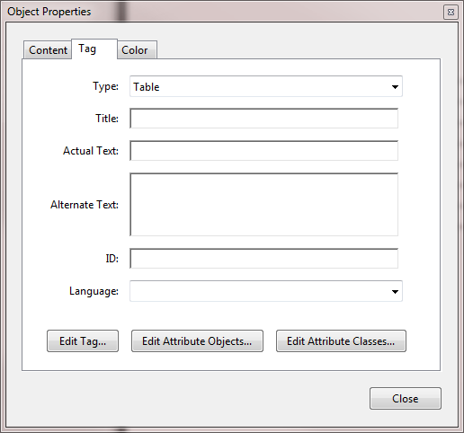

F. Define the PDF Language
The language feature is used by screen readers to the correct speech synthesis in the correct language to be read out loud.
- Open document, and click Edit on the main menu.
- Then select Preferences.
- Click on the Language option on the left. Change drop down English or Same as the operating system.
