Making Word, PPTX or Excel Documents Accessible
(ADA Compliant)

Contents
Introduction 3
A. Adding Tags to a Document. 3
New Documents 3
Existing Documents 3
B. Adding Document Title and Other Metadata 4
C. Add Styles to a Document 5
D. Use Columns Instead of Tables for Layouts 6
D. Add Alternative Text and Captions to Images, Shapes or Other Graphics. 6
E. Add Headings and Alt Text to Tables 7
F. Adding Hyperlinks 9
G. Adding Bookmarks 10
H. Define a Document Language 11
I. Convert the File to an Accessible PDF 11
J. Resources 13

Introduction
  - Before any document is placed on the Broward College Public site, it MUST be ADA complaint. Use the instructions below to ensure that your original Word, Excel or PowerPoint document will be accessible to all website users. Using these guidelines, will guarantee that all the content will be readable when a user is utilizing any assertive assistance devices (screen reader).

A. Adding Tags to a Document.
Tagging lets users read and render content using devices such as screen readers.

New Documents
- Click on File and then Save As. Under the File Name you can add Tags, Title and Subject to your document before saving.

Existing Documents
- Open an Explorer window and browse for the existing document.
- Highlight the document name and modify the Tags, Title, and Subject in the document details panel on the bottom.
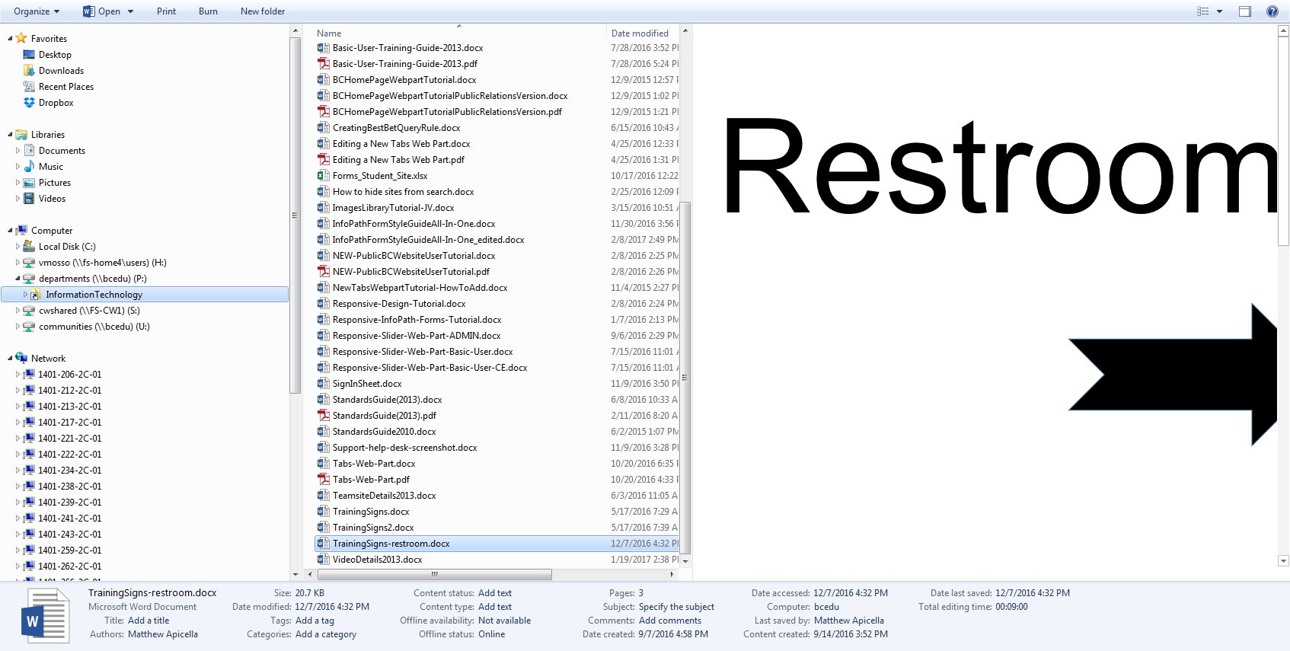

B. Adding Document Title and Other Metadata
The document title of the page makes it easily available to the user for identifying the page.
- Open the file and then click on the File tab.
- Under the Info heading, click on Properties. The choose Show Advanced Properties from the Properties drop down.
- The Document Properties pane will display on the top of the document.
- Fill out the Title, Subject, Keywords, Category and Status.
- Close the pane by clicking on the top right corner (X).
Note: After the file is converted to a PDF (use the Acrobat Tab to create PDF), then rerun the Accessibility Checker. You may notice that the title is still failing. To resolve this, set the initial view (under the Initial View Tab) as Show the Document Title.

C. Add Styles to a Document
The title states the topic of the document.

- Place cursor on the top of the page and type the document title.
- Highlight the text and use the Heading Styles under the Home tab.
- As the document is being created, make sure to use the Styles for Title, Headings, Subheadings, Bulleted List, Number Lists, etc. These Styles can also be modified by right clicking on the specific option.
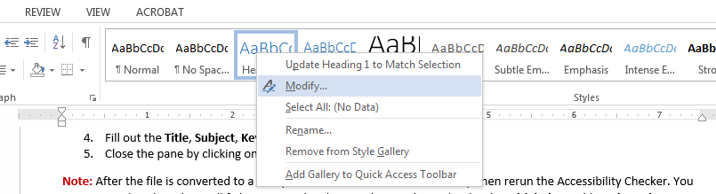

D. Use Columns Instead of Tables for Layouts
Text can be arranged into one, two or three columns without using a table. The best practice is to use the Columns option under Page Layout. Use this option instead of tables.
- Highlight the paragraph and then click on the Page Layout tab.
- Select the number of Columns from the drop down.
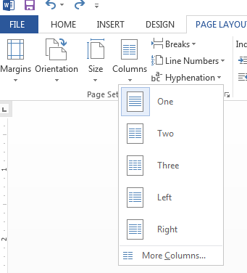

D. Add Alternative Text and Captions to Images, Shapes or Other Graphics.
If an image is used as a decoration, or background, or other purpose with no function, it should be defined as "artifact". If an image conveys information, then an alt text, description and caption should be used.

  - Select the image on the document. Then right-click to select Format Picture.
  - A panel will appear on the right side. Click on the third icon.
  - Add an Alt text and a Description.

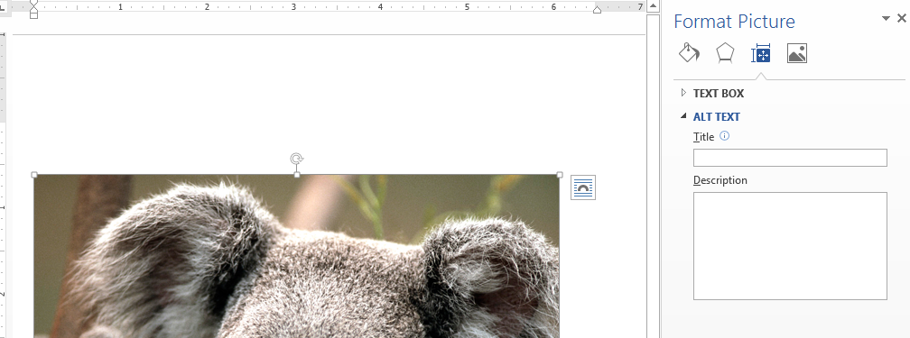

  - Next, add Captions to images by right clicking and selecting Insert Caption.

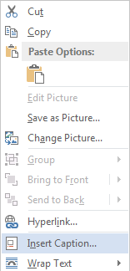

  - The following window will display. Type in a Caption, check Exclude label from caption and click Ok.
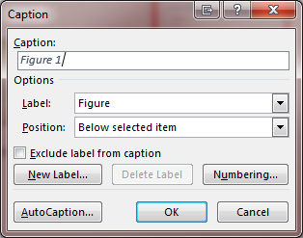

E. Add Headings and Alt Text to Tables
If a table conveys information then an alt text and description should be used. Remember use tables ONLY for tabular data NOT for layouts.

Alt Text
- Insert a table using the Table icon under the Insert Tab.

- After the table has been created. Use the Layout Tab, click on Properties.
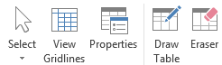
- Click on the Alt text tab.
- Fill in the Title and Description fields. Then click Ok.
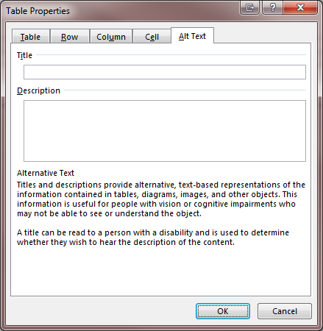
Table Heading
- Place your cursor on the table heading row (1st row).
- Under Table tools select Design. Make sure that the Header Row box is checked off.

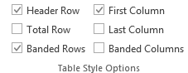

- Then place your cursor in the Header Row.
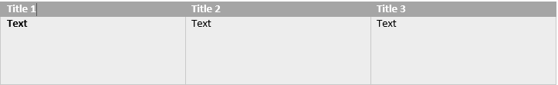

- Then place your cursor in the Header Row.

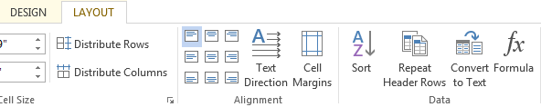

- Go to the Layout tab and click on the Repeat Header Rows. Do this for all table header rows.

F. Adding Hyperlinks
- Highlight the text and right click. Select Hyperlink.
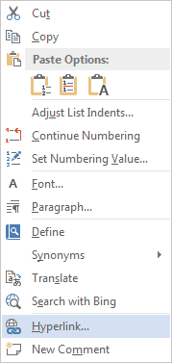
- The following window will display. Type in the Address field box.
- Click Ok.
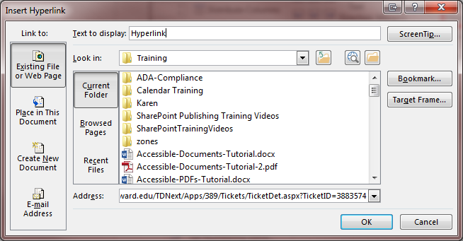

- Before the document is converted into a PDF, click on the Acrobat tab and then click on the Preferences icon.
- The following window will display. Click on the Settings tab and make sure that the Add Links box is checked.
- Then click on Ok.

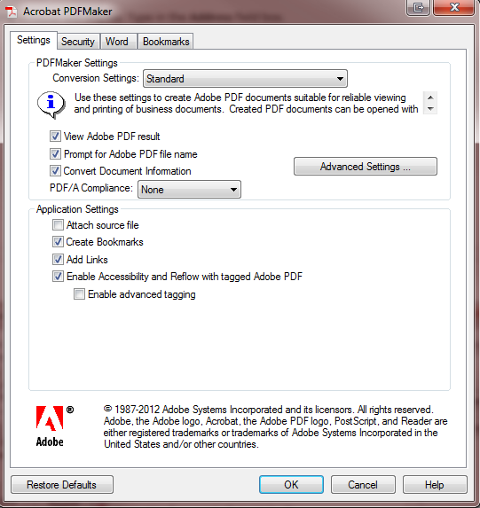

G. Adding Bookmarks
- Click on the Acrobat tab and then click on the Preferences icon.
- The following window will display. Click on the Bookmarks tab.
- Use either one of the default bookmark options like Convert Word Headings to Bookmarks or customize the bookmarks by checking the styles from the list displayed. The click on Ok.
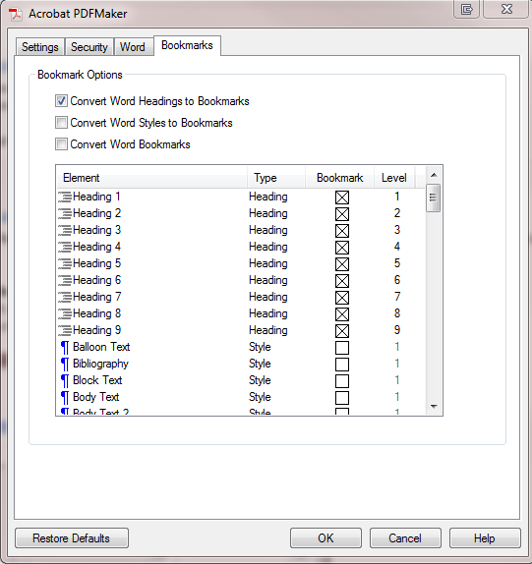

H. Define a Document Language
The language feature is used by screen readers to the correct speech synthesis in the correct language to be read out loud.

- Click on File and then select Options.
- On the left side, click on Language.
- Make sure the language is set and then click OK.
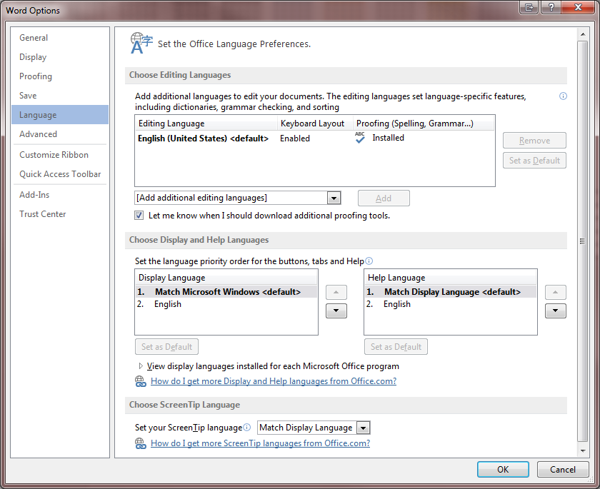

I. Convert the File to an Accessible PDF
- Click on the Acrobat tab and then click on the Preferences icon.
- The following window will display. Ensure that the Enable Accessibility and Reflow with tagged Adobe PDF is checked.

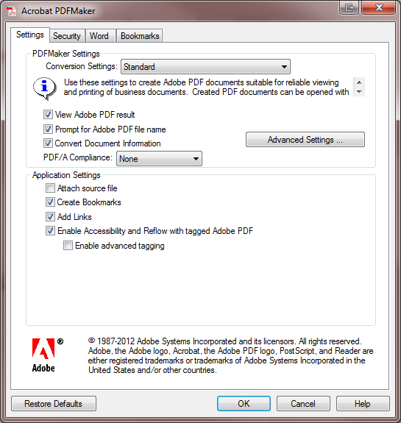

- Click Ok when completed.
- Click on the Create PDF icon. Rename the file and click Save.
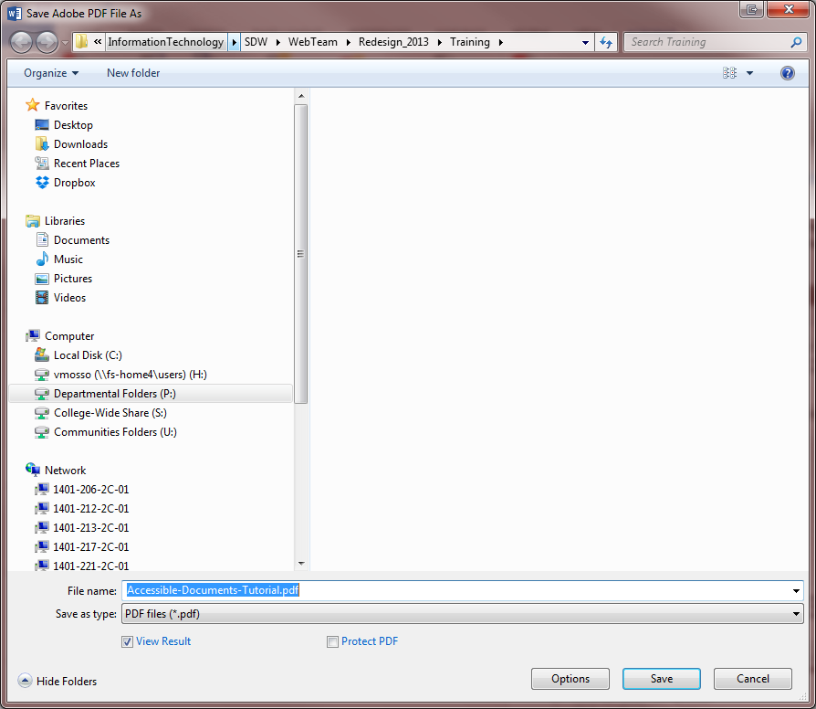
- The conversion will take a minute or two. Once it has been converted, it will then open in Adobe Acrobat. Rerun the Accessibility checker to make sure there are no ADA issues.

J. Resources

- Lynda.com: Creating Accessible PDFs by Chad Chelius
- WebAIM Color Contrast: https://webaim.org/resources/contrastchecker/
- Contrast Checker: http://contrastchecker.com/
- Adobe Acrobat Accessibility Checker: http://www.adobe.com/accessibility/products/acrobat/using-acrobat-pro-accessibility-checker.html
- Creating Bookmarks in PDF: https://www.techwalla.com/articles/how-to-create-bookmarks-in-a-pdf-acrobat-file
- Creating bookmarks in Word: https://www.youtube.com/watch?v=VbMsD-igyuQ

